Lab 3

1. theHarvester screenshots
   1. 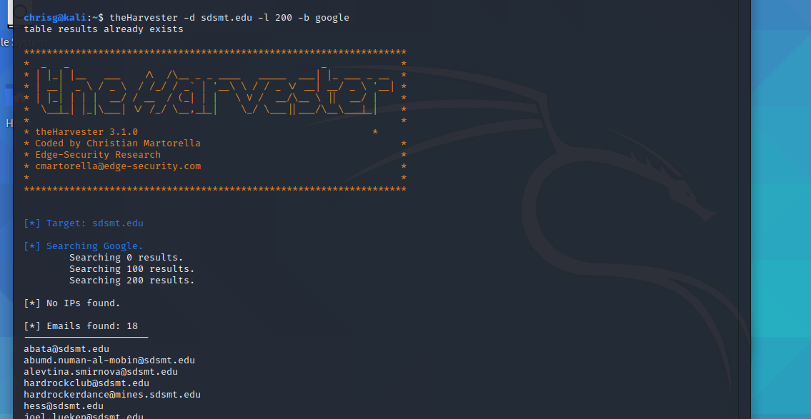

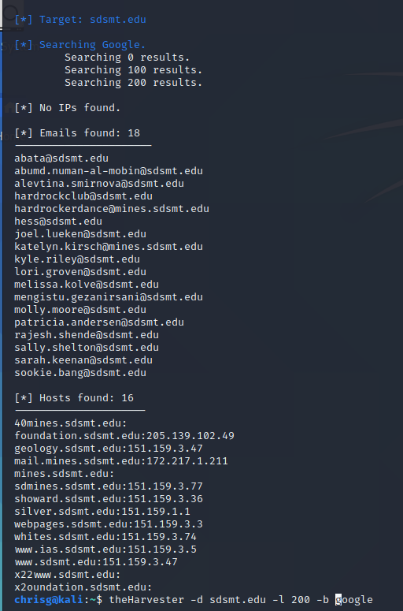  
  
Looking at the first handful of names, and first google results: many of these people are lecturers or researchers – individuals who might find it suspicious to get unsolicited emails from unknown sources, so not my first choice for targets of social engineering . Melissa Kolve seems to work in the admissions office, as a visit coordinator. Similar to a salesperson, she might be likely to respond to emails / click links / open files if provided proper context. Similarly Patricia Andersen seems to be in a position of authority at the library – not sure what you would need library systems for, but since she is in a similar public-service position she may be susceptible to the same social-engineering tactics. Maybe the library systems are connected internally to other elements of the network, compromising a host there could allow you to pivot towards elsewhere on the network.

Here are some questions to get you think about the results you got.

* 1. mail.sdsmt.edu -> email servers
  2. [www.ias.sdsmt.edu](http://www.ias.sdsmt.edu) -> acronym ->piques my curiosity since It’s not readily apparent
  3. X22www.sdsmt.edu -> odd domain name
  4. X2oundation.sdsmt.edu -> odd domain name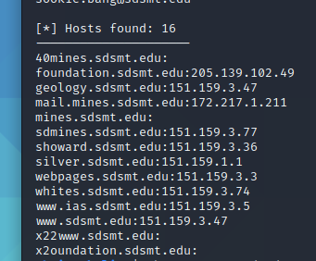
  5. Uav.sdsmt.edu -> another acronym, curious, all I think of is like Drone UAV’s  
     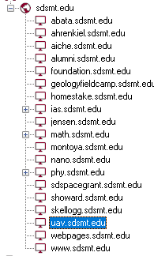  
     Otherwise most of the domains seem mundane, content sharing, lectures, public resource. I found a map of the campus, but that’s not really secret info so…

1. 0 clients, 8 servers
2. 0 users found, 0 passwords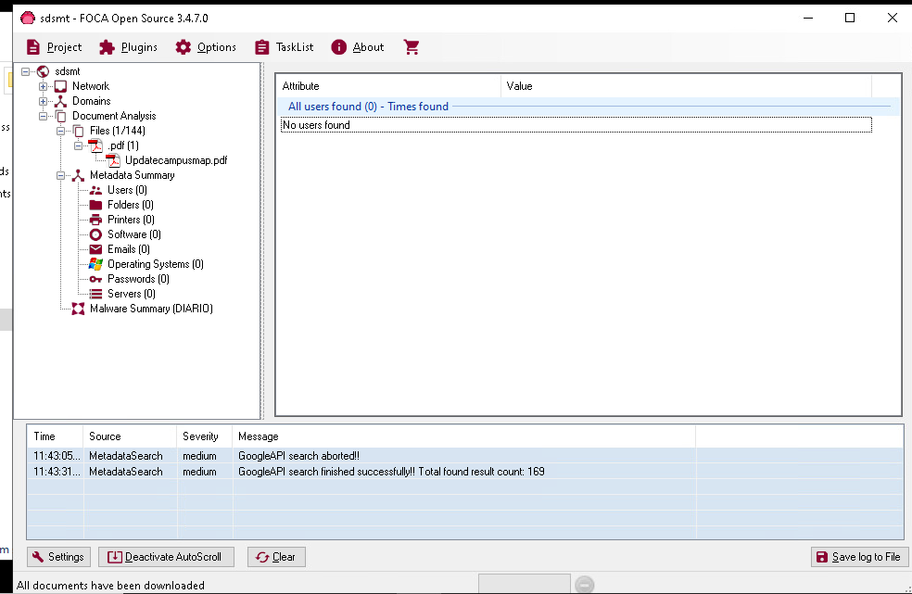
3. I found a handful of unresolved IP’s under servers, and the known domains.
   1. 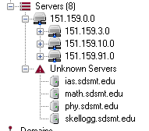
4. 0 screenshot posted above (see 3)
5. No software identified
6. No operating systems identifed
7. Over 100 identified files, which can bee pretty freely downloaded. Lectures posted for public access. Maps of the campus buildings. None that I have seen is particularly sensitive.

I felt my results were inadequate provided a lack of info on OS’s, users, and software – that being said I had similar results for both SDSU and DSU see screenshots below:

Then I exceeded my quota:  


SDSU  
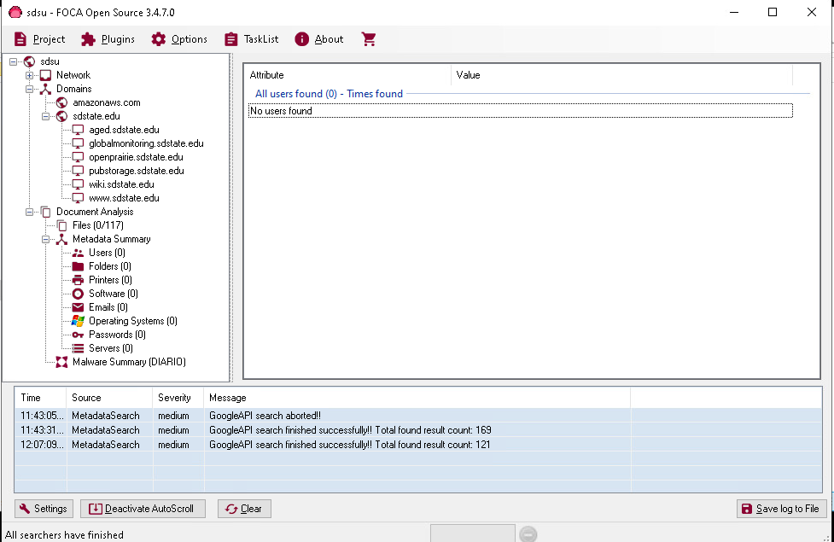

DSU

